**1. INTRODUCTION**

Here we choose the tragedy of flight : the comprehensive crash analysis. We wanna analysis that entire data . because it will be use full for future.

**2.PURPOSE**

To analyze the data on airplane crash

**Problem definition and design thinking**

**Empathy map**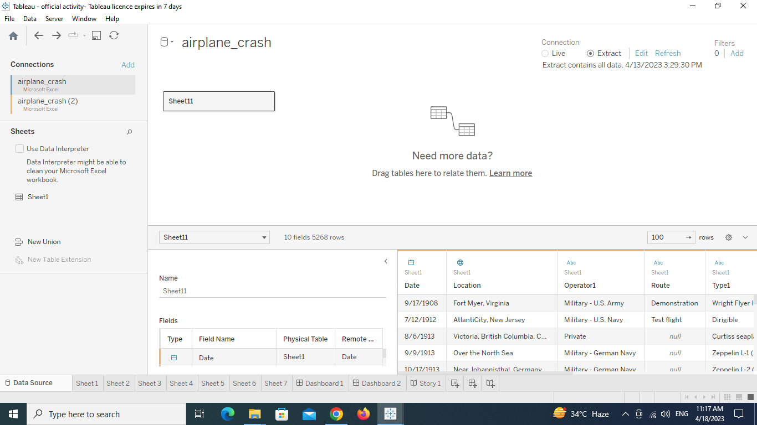

**Ideation and brainstorming map**

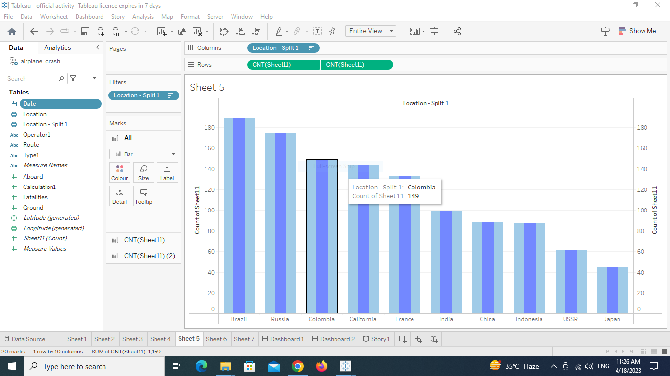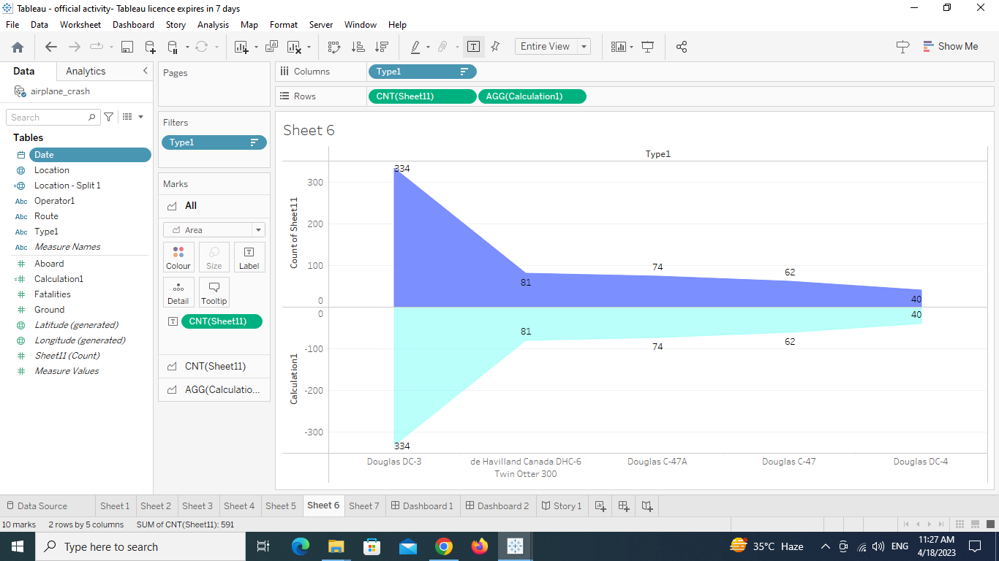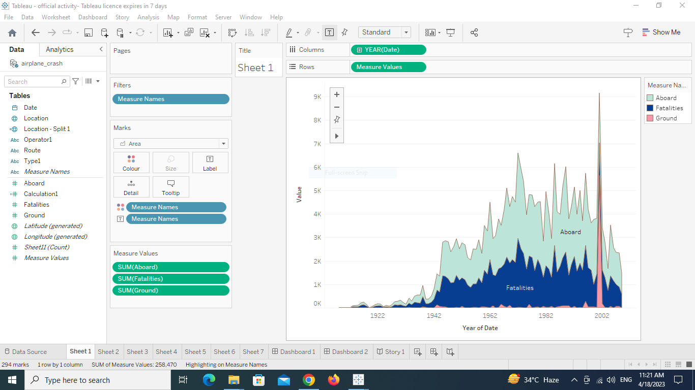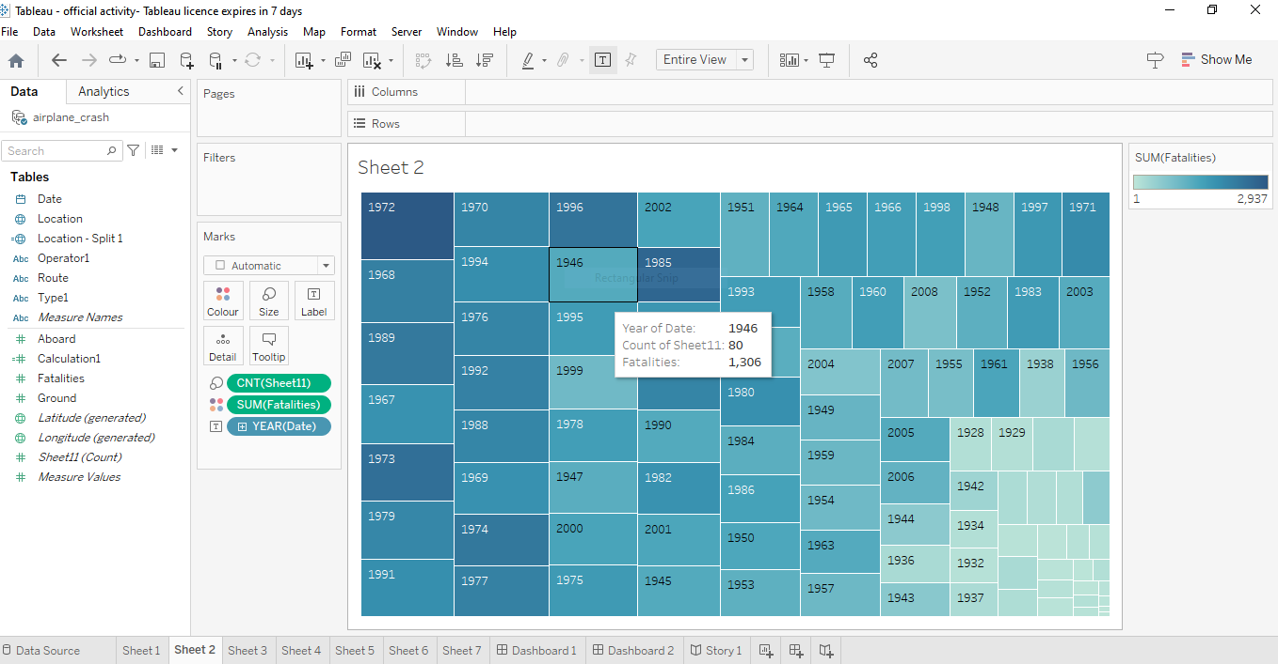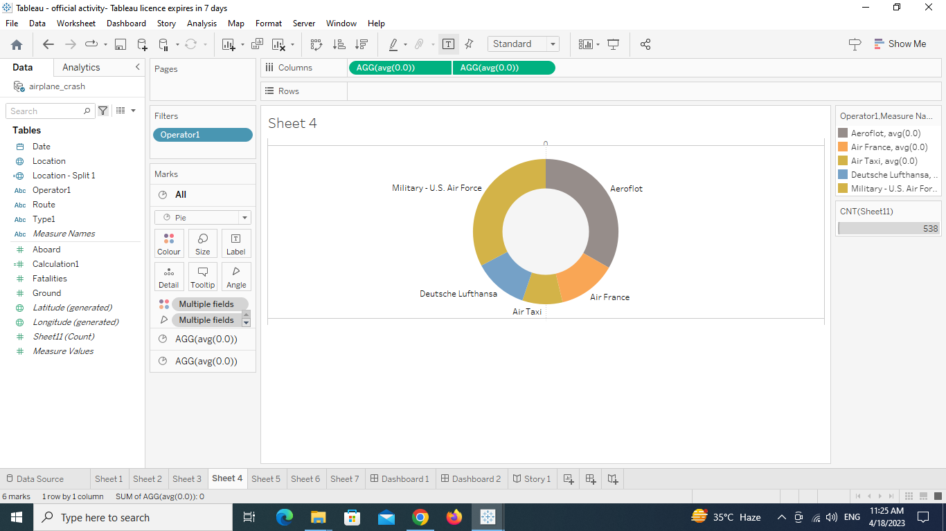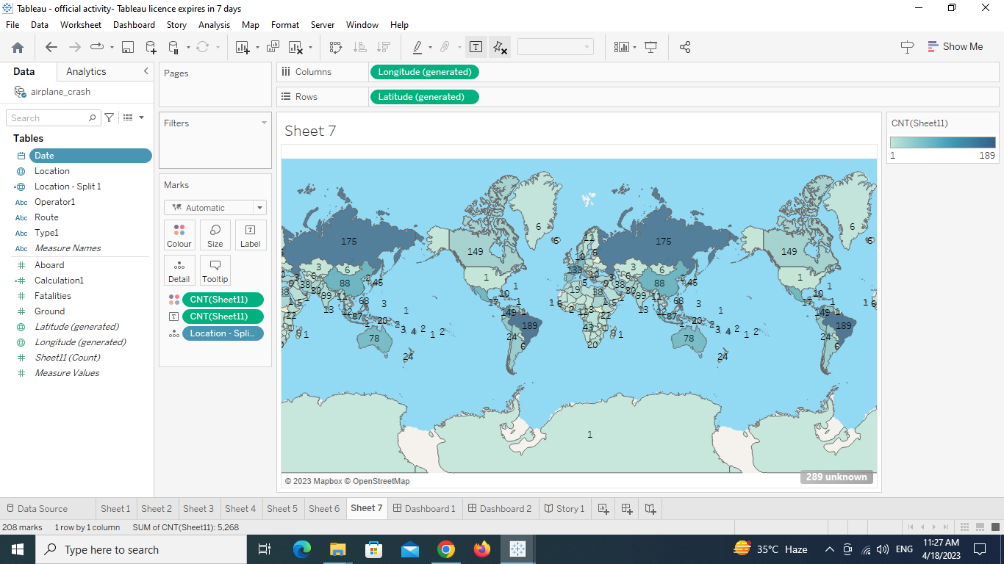

**RESULT:**

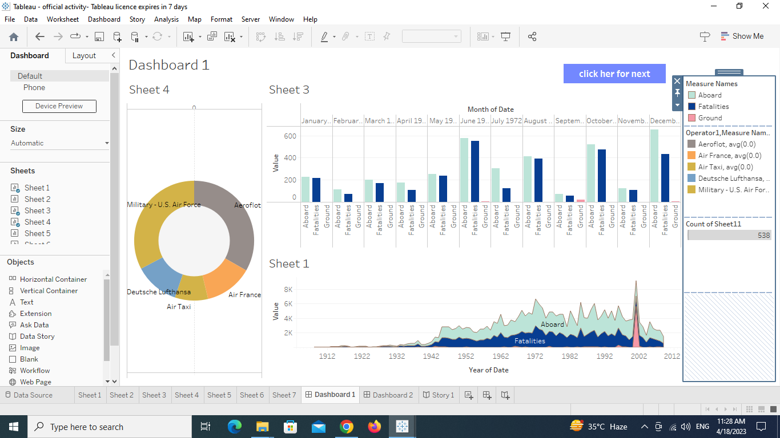

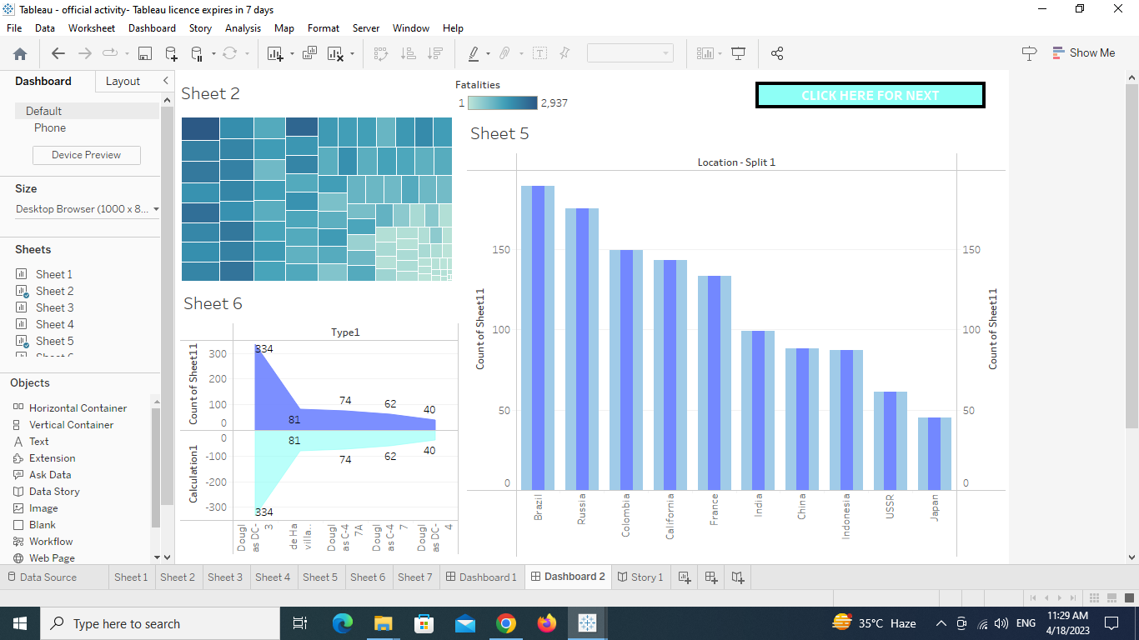

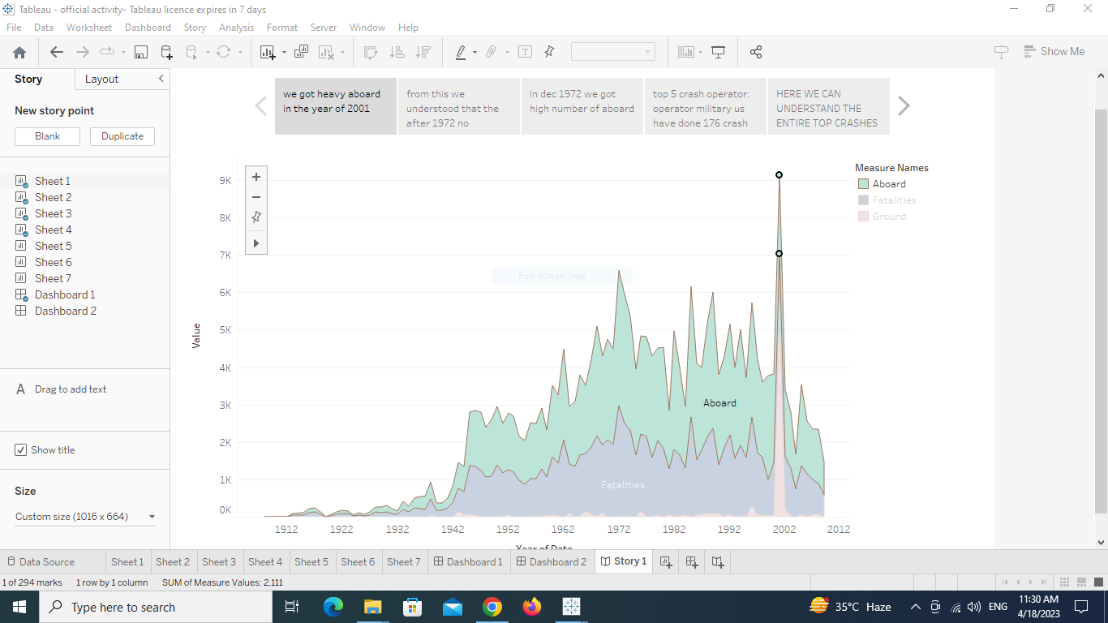

**ADVANTAGE AND DISADVANTAGES**

From this analysis we can conclude that which area , operator and what kind of problem is happened.

We can analyze the data from huge counts. That will make it easy with diagrams

Disadvantage is we need some more data to confirm our conclusion. Like why this crash is happened in theory

**APPLICATIONS**

This software provides fast analysis. Through this analysis we can easily get the solution. If you have the clear data. Data source will be get from many server like excel, my SQL, ………..

**CONCLUSION**

From this we conclude that we have to deeply investigate

The year 1972

The Brazil

And we have to deep investigate on the top 5 operator which was the reason for top counts in crashes

**FUTURE SCOPE**

My team member want to develop this like project like how much type1 crashes happened in brazil. Because brazil has more counts.

**APPENDIX**